SHARED PERSPECTIVES: PARTICIPATORY PHOTOGRAPHY AND VISUAL ANTHROPOLOGY IN THE USE OF PHOTOVOICE

OLHARES COMPARTILHADOS: FOTOGRAFIAS PARTICIPANTES E ANTROPOLOGIA VISUAL NO USO DO PHOTOVOICE

MIRADAS COMPARTIDAS: FOTOGRAFÍA PARTICIPATIVA Y ANTROPOLOGÍA VISUAL EN EL USO DEL PHOTOVOICE

 | https://doi.org/10.56238/sevened2025.036-061
Daniel Ercílio Néres, Daniel Ercílio Néres, Claudia Schemes

ABSTRACT
This article discusses Photovoice as a methodological practice situated within the field of visual and shared anthropology, oriented toward the collaborative production of knowledge and the understanding of life worlds shaped by intersectional identities. Drawing on an empirical experience conducted with seven participants of diverse profiles — including individuals with visual impairments — the study analyzes the process of image production, interviews, and collective meetings, examining how photography can operate simultaneously as an ethnographic artifact, an enunciative device, and a space of collective care. The methodological steps included media literacy, free image production, individual pre-selections, discussion groups, and analytical feedback sessions, with emphasis on accessibility and ethical reflexivity. The analysis of the images and narratives revealed tensions between visibility and protection, agency and vulnerability, highlighting the political and sensorial potency of the image as a space of negotiation and encounter. The work is situated within the tradition of shared anthropology and within decolonial and multisensory epistemologies, proposing a reading of photography as a gesture of sharing and an instrument of symbolic resistance.

Keywords: Intersectionality. Ethnography. Photovoice. Qualitative Methodology. Accessibility.

RESUMO
Este artigo discute o Photovoice como uma prática metodológica situada no campo da antropologia visual e compartilhada, orientada à produção colaborativa de conhecimento e à compreensão de modos de vida atravessados por identidades interseccionais. A partir de uma experiência empírica realizada com sete participantes de perfis diversos — incluindo pessoas com deficiência visual —, o estudo analisa o processo de produção de imagens, entrevistas e encontros coletivos, observando como a fotografia pode operar simultaneamente como artefato etnográfico, dispositivo de enunciação e espaço de cuidado coletivo. As etapas metodológicas compreenderam alfabetização midiática, produção livre de imagens, pré-seleções individuais, grupos de discussão e devolutivas analíticas, com ênfase na acessibilidade e na reflexividade ética. A análise das imagens e narrativas revelou tensões entre visibilidade e proteção, agência e vulnerabilidade, destacando a potência política e sensorial da imagem como espaço de negociação e de encontro. O trabalho inscreve-se na tradição da antropologia compartilhada e nas epistemologias decoloniais e multissensoriais, propondo uma leitura da fotografia como gesto de partilha e instrumento de resistência simbólica.

Palavras-chave: Interseccionalidade. Etnografia. Photovoice. Metodologia Qualitativa. Acessibilidade.

RESUMEN
Este artículo discute el Photovoice como una práctica metodológica situada en el campo de la antropología visual y compartida, orientada a la producción colaborativa de conocimiento y a la comprensión de modos de vida atravesados por identidades interseccionales. A partir de una experiencia empírica realizada con siete participantes de perfiles diversos —incluyendo personas con discapacidad visual—, el estudio analiza el proceso de producción de imágenes, entrevistas y encuentros colectivos, observando cómo la fotografía puede operar simultáneamente como artefacto etnográfico, dispositivo de enunciación y espacio de cuidado colectivo. Las etapas metodológicas comprendieron alfabetización mediática, producción libre de imágenes, preselecciones individuales, grupos de discusión y devoluciones analíticas, con énfasis en la accesibilidad y en la reflexividad ética. El análisis de las imágenes y narrativas reveló tensiones entre visibilidad y protección, agencia y vulnerabilidad, destacando la potencia política y sensorial de la imagen como espacio de negociación y encuentro. El trabajo se inscribe en la tradición de la antropología compartida y en las epistemologías decoloniales y multisensoriales, proponiendo una lectura de la fotografía como gesto de compartir y como instrumento de resistencia simbólica.

Palabras clave: Interseccionalidad. Etnografía. Photovoice. Metodología Cualitativa. Accesibilidad.

1 INTRODUCTION
In a world saturated with images and crossed by narrative disputes, visual production has become a privileged terrain to understand the relationships between representation, power and experience. In contemporary anthropology, photography has ceased to be a mere recording instrument to assume the status of relational language — a way of thinking and feeling the field. As Sylvia Caiuby Novaes (2017, p. 13) observes, photography "is not just a mirror of reality, but a translation that is built in the encounter", evidencing the performative and dialogical dimension of visual practices.
The Photovoice method, created by Wang and Burris (1997), is inscribed in this epistemological shift by placing the camera in the hands of the participants, redistributing the possibilities of enunciation and authorship. More than democratizing the gaze, it is a way of narrating the world from the margins — a gesture of co-authorship that gives back to the subjects the right to represent themselves. However, its application in multisensory ethnographic contexts, especially with visually impaired people, remains little explored in the anthropological literature, which reveals a theoretical and methodological gap to be addressed.
The theme of this study focuses on Photovoice as a participatory methodology situated in the field of visual anthropology, analyzing its ethical, political and sensorial power. The research problem of the study can be summarized in the following question: how can the Photovoice method, articulated with shared anthropology and decolonial and multisensory epistemologies, produce practices of co-authorship, care, and symbolic resistance among subjects crossed by intersectional markers of gender, race/color, and disabilities?
The overall objective is to understand how Photovoice can operate as a collaborative practice of knowledge production and collective care in the field of visual anthropology, especially in contexts of sensory and intersectional diversity. To this end, it seeks to: (a) analyze how the method is inserted in the tradition of the anthropology of the image in a shared posture (b) investigate the practical process of production and discussion of images among participants, observing dimensions of visibility, vulnerability and agency; (c) to examine the methodological adaptations that allowed the participation of blind and low-vision people; (d) reflect on the ethical and epistemological implications of participatory methodologies; and (e) propose a conceptual expansion of visual anthropology.
The research was developed between February and March 2024, in a process consisting of five virtual collective meetings and seven individual interviews, carried out with the support of accessibility software and screen readers. Seven people participated, with diversity of gender, race/color, ages, modes of perception and body shapes. Among them, there were blind and low-vision participants, as well as people who declare themselves black, trans, elderly and in fat bodies; There were also reports of long-standing motor limitations. The research team was composed mostly of white people and included a blind researcher, as well as gay and fat body members. The individual breakdown was discussed in continuous consent and is aggregated here to protect privacy." The conduct of the activities was planned in an accessible way, ensuring that all stages — from the mediation of conversations to the reading of images — could occur in an inclusive and dialogical way. It is noteworthy that the description of social markers was self-reported and the level of detail negotiated with each person, applying the principle of data minimization to reduce the risk of re-identification in small samples. Consent was continuous and reviewable.
The meetings took place in a virtual environment, with time and rhythm adjusted to the needs of the group, and privileged listening, touch and imagination as legitimate forms of sensory experience. The field was conducted under principles of horizontality and co-authorship, ensuring that each person could define their own forms of expression — through photography, sound, collage, writing, or oral storytelling. This methodological choice sought not only to record the visible world, but to welcome multiple forms of perception and production of meaning.
It is based on the hypothesis that Photovoice, when articulated with principles of accessibility and reciprocity, can constitute itself as a practice of co-authorship and symbolic reparation, redistributing the power to narrate and represent. In addition, it is assumed that the inclusion of blind and low-vision participants expands the notion of visuality, demonstrating that anthropological knowledge can emerge from a multisensory field of relationships and affects.
Methodologically, it is a qualitative and exploratory study inserted in the tradition of shared anthropology (Rouch, 2003; Eckert & Rocha, 2003). The investigation was based on collective and individual meetings that combined media literacy, image production, group discussions and analytical feedback. The steps were documented through audio and video records, and field diaries, with collaborative validation of interpretations and continuous ethical consent. This approach sought to ensure accessibility, horizontality and reflexivity, transforming Photovoice into a practice of sensory and political research.
By mobilizing the contributions of shared anthropology (Rouch, 2003; Novaes, 2017) and decolonial and multisensory epistemologies (Smith, 2021; Howes, 2022), the study proposes to understand photography not only as an ethnographic artifact, but as a gesture of sharing and political practice of the sensitive. The theoretical framework articulates four interdependent axes that sustain the reading of Photovoice as an ethnographic practice of co-authorship and care: (1) visual and shared anthropology, which is based on Eckert and Rocha (2003), Novaes (2017) and Rouch (2003, 2015), emphasizing collaborative making and the return of images to the context of origin; (2) intersectionality, based on Patricia Hill Collins (2022) and Gama (2017), which allows us to understand the overlaps between gender, race, class, and body as entanglements of visibility and vulnerability; and (3) multisensory anthropology, supported by Howes (2022), MacDougall (2006), Kleege (2018) and Bolt (2021), which shifts visuality to a field of embodied and inclusive perception. It is argued, therefore, that Photovoice, when articulated with these references and guided by principles of accessibility and reciprocity, destabilizes visual hierarchies and produces alternative ways of seeing, hearing and existing in common

2 THEORETICAL FRAMEWORK
2.1 VISUAL ANTHROPOLOGY AND THE SHARED GESTURE
Visual anthropology has consolidated itself as a field of experimentation situated between science, art and politics. Since Jean Rouch (2003; 2015), the camera has come to be seen as a mediator of encounters and not as a simple instrument of capture. Rouch inaugurated an ethics of sharing that shifts the researcher from a place of observer to that of participant in a collective process of creation and interpretation — what he called cinema verdade and, later, shared anthropology.
In Brazil, Cornelia Eckert and Ana Luiza Carvalho da Rocha (2016) broaden this horizon by proposing the notion of "anthropology of the image", understood as a disciplinary field that seeks to understand the relationships between image, visuality, and anthropological research practices. The authors note that, historically, anthropology was a predominantly written discipline, in which images and sounds were used as illustrative appendices. However, with the advancement of audiovisual and digital technologies throughout the twentieth century, the use of the image began to be recognized as a legitimate form of knowledge production. Inspired by the contributions of Margaret Mead and Gregory Bateson, Eckert and Rocha (2016) argue that the anthropology of the image should explore the "semantic fields" and institutional devices that integrate the visual and the sound in ethnographic production, opening space for new languages and for the dialogue between art, science and technology.
Photovoice directly inherits this principle, allowing participants to produce their own images and, with them, new meanings about their experiences. By placing the camera in the hands of those who are usually the object of research, the method becomes a device for authorship and redistribution of the gaze. However, as Liebenberg (2018) emphasizes, this delivery of the camera is not automatically emancipatory. The author proposes a critical reflection on the risks and contradictions inherent to the use of images in participatory contexts, pointing out four fundamental dimensions:
(1) the risk of exploitation and oppression, when images are used without ethical return processes and without the informed and continuous consent of the participants; (2) the subjectivity of interpretation, since the meaning of images is always situated and depends on the experiences and social contexts of those who produce and read them; (3) the limited impact on social change, when the circulation of images ignores aspects of visual literacy, cultural translation and political mobilization; and(4) the challenges in dissemination and public impact, especially when it is not planned how and to whom the results will be shared.
These criticisms reinforce that Photovoice requires more than the production of images: it requires an ethical and intentional commitment to the processes of co-interpretation, feedback and circulation of photographs. Without this, there is a risk of repeating the same hierarchies of power that the method seeks to question. Thus, the value of the ethnographic image lies not only in its representational capacity, but in its relational potency — as a space for care, listening, and the construction of common worlds.

2.2 INTERSECTIONALITY AND DECOLONIAL EPISTEMOLOGIES
Intersectionality, as proposed by Patricia Hill Collins and Sirma Bilge (2016), is an analytical tool that allows us to understand the complexity of human experiences in their social, political, and cultural dimensions. By recognizing that life events are shaped simultaneously by multiple factors — such as gender, race, class, and disability — the authors propose an approach that rejects one-dimensional readings of inequalities. This perspective shifts the gaze from isolated categories to the relational plots that structure oppression, revealing how different social markers intersect and reinforce each other.
More than a theoretical concept, Collins and Bilge (2016) understand intersectionality as critical praxis — a way of articulating research and transformative action. This double dimension, analytical and political, moves intersectionality away from a merely descriptive use and reinserts it in the field of collective struggles, where theory and practice co-implicate each other. The authors (Collins & Bilge, 2016) argue that knowledge is only emancipatory when it is born from a dialogical movement between bodies and territories, which brings them closer to a situated and insurgent epistemology. Thus, intersectionality is not only a methodology for analyzing inequalities, but a way of thinking and acting committed to social justice and the redistribution of the power to narrate.
In the Latin American context, intersectional reading gains density by dialoguing with authors such as Fabiene Gama (2016), who proposes an anthropology sensitive to emotions, affections, and embodied forms of expression. In his work on political demonstrations in Bangladesh, Gama demonstrates how images and emotions become devices for mobilizing and critiquing the classical dichotomies of anthropology, such as reason and emotion, body and mind, reality and fiction. Such a perspective converges with the intersectional proposal by refusing epistemological hierarchies and emphasizing the forms of knowledge that emerge from the body and lived experiences.
These articulations reveal that the challenge of intersectionality is not only to identify the overlapping of oppressions, but to reconfigure the very forms of knowledge that sustain them. By recognizing that experience is a site of theoretical production, intersectionality operates as a frontier epistemology—a practice of translation and resistance between worlds. In this sense, when applied in multisensory ethnographic contexts, such as those proposed in this study, it allows us to think of the body, gender and race not as fixed markers, but as relational dimensions that cross the ways of seeing, feeling and representing the world.

2.3 MULTISENSORIALITY AND ACCESSIBILITY AS EPISTEMOLOGY
The anthropology of the senses, as proposed by David Howes (2022), invites us to understand knowledge as an embodied and situated experience, in which each culture organizes and values the senses in its own ways. Perceptual hierarchies—the predominance of vision in Western societies, for example—are not universal, but cultural constructs. Howes argues that multisensory studies should comparatively investigate these sensory ecologies, recognizing that feeling is always collective and relational. Such a perspective also implies an epistemological openness to embrace non-Western paradigms of perception, in which seeing, hearing, touching, and imagining are intertwined in forms of knowledge that challenge the separation between body and mind.
This approach is echoed in the visual and filmic anthropology of David MacDougall (2006), who conceives the image as a way of thinking with the body. In The Corporeal Image, the author argues that sensory ethnography is not limited to observation, but emerges from contact—from physical presence, ambient sound, gesture, and breathing. The camera, in this context, becomes a perceptive extension of the researcher and the participants, establishing a field of sensory exchanges that mobilizes all the senses. MacDougall proposes an expanded visuality, in which knowledge is not only represented, but lived.
By integrating people with different forms of perception, the Photovoice project revealed that seeing is also listening, imagining and touching. The collective exercise of translating experiences through photography, narration and sound made visible the plurality of ways of perceiving the world. From Georgina Kleege (2018), it is understood that blindness — or any perceptual variation — is not absence, but another form of presence. The images produced by participants with little or no vision expanded the concept of photography, transforming it into tactile, auditory and imaginative gesture. In this sense, the right to image is expanded: it is also the right to perception and sensory expression in its multiple languages.
The thought of David Bolt (2019) offers a critical basis for this expansion. Its tripartite model — between normative positivisms, non-normative negativisms, and non-normative positivisms — allows us to understand how certain forms of perception are marginalized while others are elevated to the norm. Bolt advocates a pedagogy that recognizes these differences not as failures, but as sources of insight. The "cryptaemologies", in their formulation, challenge the privilege of the dominant epistemes and propose a liberating education, based on dialogue and collaboration between different ways of existing and knowing.
Thus, accessibility is understood here not only as a technical adaptation, but as an epistemological and political principle. Researching and creating in an accessible way means recognizing that knowledge is born from the relationship between bodies, sounds, images and affections. Photovoice becomes, in this horizon, an expanded and liberating sensory method — a practice of co-authorship in which perceptual difference is cognitive and ethical power. By relating different experiences of the sensible, the study reaffirms that every form of knowing is, above all, a way of sharing the world.

3 METHODOLOGY
3.1 METHODOLOGICAL DESIGN
The methodological design was conceived as a report of ethnographic experience, developed from a collective process of visual creation and reflection. The study had seven participants, intentionally selected in order to ensure diversity of gender, age group, race/ethnicity, disability and social class.
Among them, there were people with low vision and total blindness, which allowed them to explore multisensory dimensions of image production, both among the researchers and among the participants. This plural composition reflects the conception of Patricia Hill Collins (2022), according to which intersectionalities should be understood as networks of relationships that configure positions and experiences, and not as a simple sum of inequalities.

3.2 RESEARCH STAGES
Data collection was organized in five main stages, articulating training meetings, visual productions, individual interviews and moments of collective feedback. All phases were planned based on principles of accessibility, horizontality and ethical reflexivity.
a) Initial meeting — Collective construction and media literacy
The first meeting had an introductory and formative character. The objectives of the research were presented, ethical aspects were discussed and the set of generating questions that would guide the production of images was collectively elaborated. This session included a media literacy workshop, focused on reflection on framing, consent and visual narrative.
b) Production of images (10 days)
For ten days, the participants produced images from the collectively elaborated questions, using cell phones, digital cameras or alternative resources, such as sound recordings, collages and textual descriptions. This plurality was fundamental to ensure inclusion and expressive freedom, especially in the case of people with visual impairments.
(c) Individual pre-meetings – Selection and negotiation of consents
Each participant held an individual meeting with the researchers, presenting the set of materials produced, performing a pre-selection and discussing issues of anonymity, exposure and circulation of images. These moments functioned as spaces for listening and ethical negotiation, in which consent was treated as a continuous process, as argued by Liebenberg (2018) and Catalani & Minkler (2010).
d) Collective meeting — Presentation and discussion of the images
In a group, each participant chose three images to share. After each exhibition, the collective produced a "force-word" that synthesized the symbolic or affective meaning of the photograph. This exercise promoted a space for co-interpretation and sharing, transforming the group into a community of analysis and care.
e) Analytical feedback
The process ended with a final feedback meeting, in which the researchers presented preliminary readings of the images and narratives. The interpretations were submitted to the group's review, ensuring traceability, transparency and co-authorship in the construction of the results.

3.3 ETHICS AND TRACEABILITY
Ethics was understood as a situated and continuous practice, not restricted to a formal stage of approval. Consent was renegotiated throughout the process, and participants had the autonomy to remove materials, modify authorizations or decide on the public destination of the images. Concrete counterparts were offered, such as the printing of photographs, the holding of a community exhibition and the writing of a collective manifesto-text.
As Hikiji (2018) argues, the ethnographic image only acquires full meaning when it returns to the field and is re-inscribed in the exchanges and affections that originated it. From this perspective, ethics is not limited to avoiding harm, but implies promoting reciprocity, recognition, and mutual care.
In this way, all meetings were recorded in audio and video, with formal authorization. The researchers prepared individual field diaries and a collective notebook with observations and reflections. The analysis of the corpus was based on methodological triangulation — between images, speeches and field notes — and on collaborative validation strategies, during feedback and collective reviews.

3.4 ACCESSIBILITY AND MULTISENSORY ANTHROPOLOGY
The participation of blind and low-vision people required methodological adaptations that became a constitutive part of the project's epistemology.
Standardized sound descriptions were created for all images, audio versions of the instructions, and the use of software compatible with screen readers. During the meetings, the images were described aloud and commented collectively, promoting an environment of sensory listening and shared interpretation.
These practices materialized what Fabiene Gama (2016) calls multisensory ethnography, in which knowledge emerges from bodily and affective interactions, and not only from visual observation. Thus, Photovoice was re-signified as an expanded sensory practice, capable of including and valuing different modes of perception and presence in the ethnographic field.

4 RESULTS AND DISCUSSION
The analysis of the material produced and the collective interactions revealed dimensions that go beyond the simple application of Photovoice as a participatory technique. The process proved to be a field of sensory and political learning, in which the boundaries between researcher and participant, between image and word, between seeing and feeling, were constantly negotiated.

4.1 THE IMAGE AS A RELATIONAL DEVICE
The delivery of the camera and other expressive means to the participants not only democratized visual production, but reconfigured the very idea of authorship. The images emerged as relational events, crossed by affection, memory and imagination.

Figure 1
The Diary of a Magician
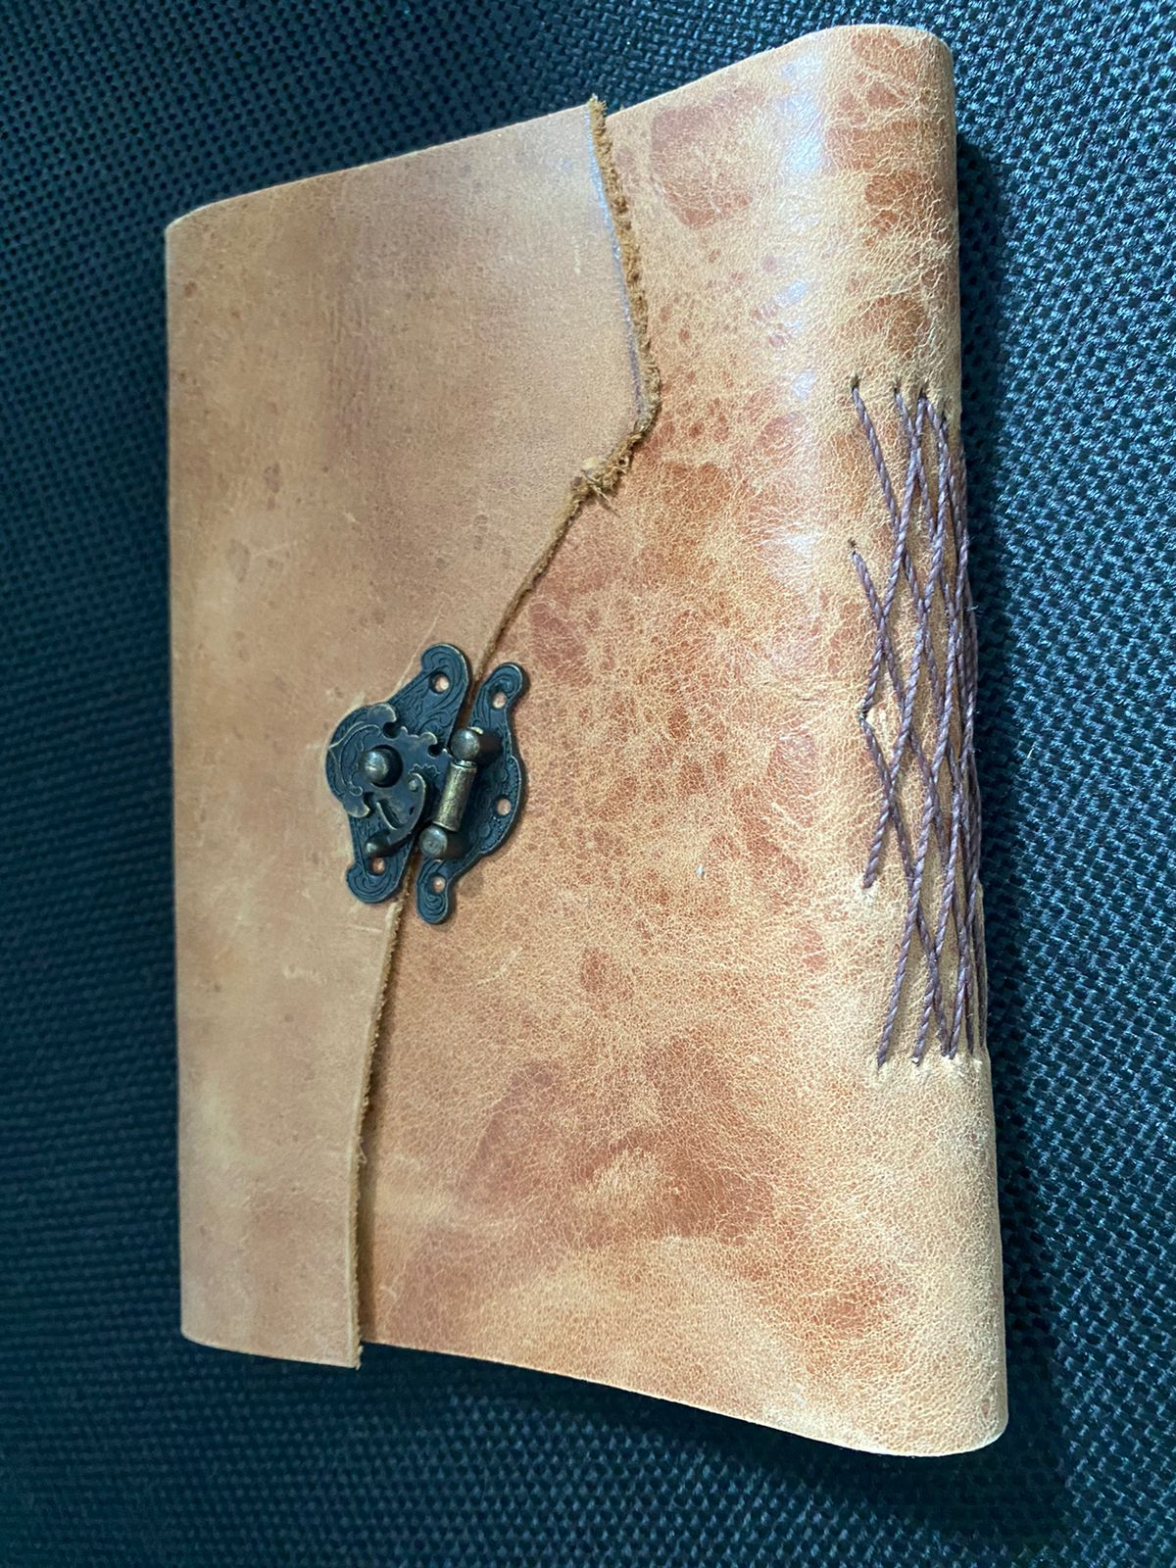
Photograph produced by a participant during the Photovoice stage, in response to the question: "What has changed and what has changed in me? What phases and mutations have I gone through that have passed me by?" Source: Photovoice research collection (2024). Publication authorized by the participants.

As Novaes (2017) points out, ethnographic photography is always an encounter. In collective meetings, everyday objects — canes, windows, shadows — have become symbolic operators of belonging and transformation. The group not only analyzed images, but produced bonds, sharing experiences of the body and resistance.

4.2 INTERSECTIONALITY IN IMAGE: BETWEEN VISIBILITY AND VULNERABILITY
The diversity of the group brought different regimes of visibility. Black participants, LGBTQIA+ participants, and blind or low-vision participants exposed tensions between showing up and protecting themselves. This ambiguity confirms Smith's (2021) warning: the risk of participatory practices becoming new forms of symbolic extraction. For this reason, Photovoice proved to be a space for continuous negotiation — each image was also an ethical decision about what to display and what to silence.
During the discussions, recurrent tensions emerged: the desire to show oneself and the fear of exposure; the desire to represent oneself and the awareness of the risk of stigmatization. These ambiguities echo Linda Tuhiwai Smith's (2021) concerns about the danger of transforming participatory practices into new mechanisms of symbolic extraction. Thus, decisions about circulation, subtitles and public uses became a constitutive part of the analytical and ethical process.

Figure 2
Coat
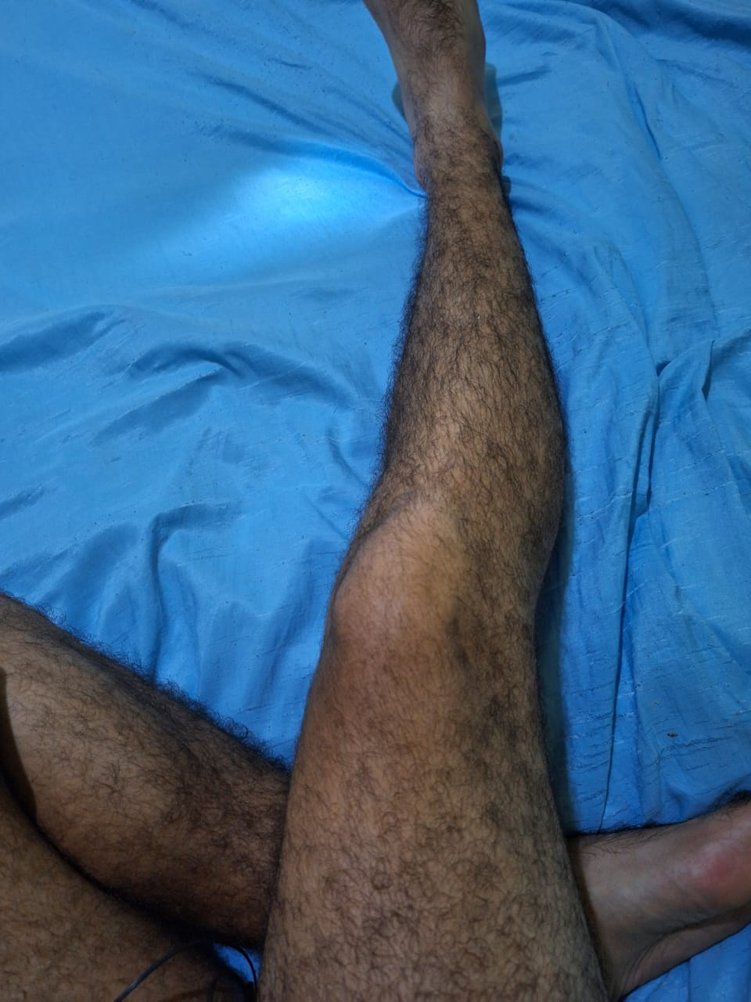
Source: Photograph produced by a participant during the Photovoice survey, in response to the question: "Where is the discomfort — mine and others'? Where and how do I need to adapt?"
Source: Photovoice research collection (2024). Publication authorized by the participants.
Each photograph, read together with their narratives, revealed a space for negotiation between saying and being silent. The interpretations did not seek consensus, but multiplicity. This polysemy is consistent with what Gama (2017) calls the "emotional density of images", in which each gaze contains layers of memory, desire, and care.
Photovoice, in this context, proved to be not only a research method, but a space for symbolic elaboration — a field of care, in which the act of showing can be, at the same time, vulnerable and reparative.

4.3 ACCESS, SENSORIALITY AND EPISTEMOLOGICAL DISPLACEMENTS
The inclusion of blind people has redefined the very idea of visuality. The images were also sounds and descriptions. This experience confirmed MacDougall's (2006) proposal that the body is the first instrument of observation. Photovoice, in this context, has become a laboratory of sensoriality and imagination, reaffirming that the perceptual difference is a source of knowledge.
The participation of blind people, both among the surveyed and among the researchers, destabilized conventional conceptions of "visuality". The dynamics of description and collective listening showed that the image is also sound, texture, rhythm. What is produced, in this sense, is a multisensory anthropology, where the gaze is replaced by the sensitive presence.

Figure 3
The dark and the wind
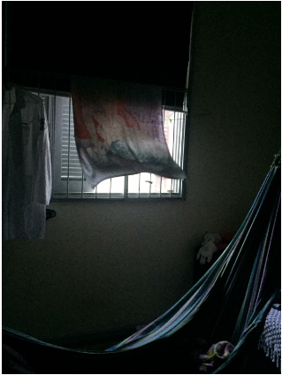
Source: Photograph produced by a participant during the Photovoice stage, in response to the question: "Who is the author? Where and who am I?" Source: Photovoice research collection (2024). Publication authorized by the participants.
For David MacDougall (2006), the body is the first instrument of anthropological observation. This proposition found practical resonance in the project: by welcoming other forms of perception, the group expanded the field of the visible and opened paths for what Bolt (2021) calls cultural studies of disability, in which sensory difference becomes epistemological power.
This displacement requires visual anthropology to rethink its own denomination. If the image is an event, and if the event involves multiple senses, then the field is not limited to the "visual", but to relational and embodied experience. Photovoice, in this case, not only documents, but also transforms — the way of seeing, hearing and understanding the other.

5 CONCLUSIONS
The study confirmed that Photovoice, when articulated with shared anthropology and epistemologies of the sensible, is more than participatory methodology: it is an ethical and political practice of co-authorship. The images and narratives produced revealed that photography can operate as a gesture of care and symbolic resistance. Specifically, regarding the inclusion of blind participants, it showed that visuality is a form of relationship, and not an attribute of the gaze.
Visual anthropology, therefore, expands into a multisensory anthropology — capable of recognizing in sensory differences the power of encounter and collective creation. The experience with blind participants introduced decisive shifts: by requiring methodological and communicative adaptations, the group became a laboratory of sensoriality and imagination. This learning showed that visuality is not an attribute of the gaze, but a form of relationship. Thus, visual anthropology, by embracing practices of listening, touch, and imagination, is transformed into multisensory anthropology, capable of recognizing the power of perceptual differences as an epistemological engine.
From an ethical and political point of view, the research reaffirmed that there is no shared anthropology without protocols of reciprocity and dynamic consent. Co-authorship must translate into real decisions about circulation, anonymity, credit, and return of results, ensuring that the image is not appropriated, but shared. This requires recognizing Photovoice as a practice of symbolic reparation — a way of giving people back the right to represent themselves, and to participate in decisions about the fate of their narratives.
Analytically, the results show that intersectional identities do not add up in a linear way: they become entangled in situated experiences that challenge the conventional categories of social research. The method revealed the power of these intersections by allowing multiple layers of subjectivity to emerge in images and words, configuring a plural and sensitive ethnography.
As Eckert and Rocha (2003) state, the image is always negotiation; as Novaes (2017) reminds us, its meaning is born from the encounter; and, according to Paulo Freire (2022), every shared process must serve freedom and collective transformation. Photovoice, in this sense, proved to be a pedagogical and political space, in which the act of looking is also the act of freeing oneself from the imposed narratives.
In dialogue with the initial objectives, this study sought to understand how Photovoice, articulated with shared anthropology and multisensory epistemologies, can become a method of co-authorship, care and symbolic resistance. The methodological path confirmed the hypotheses that guided the work: the perceptual difference is cognitive power; accessibility is an epistemological principle; and photography, when shared, becomes the political language of the sensitive. Thus, the lived field reaffirmed that knowledge is not produced about others, but with others — in processes of listening, reciprocity and collective imagination
The research, in the end, produced a double movement: methodological and existential. For the participants, the process represented an opportunity to express themselves and to reconfigure their relationship with their own bodies and with the world. For the researchers, it implied ethical and sensory learning, a re-education of looking and listening. This circularity confirms that shared anthropology is less a method than an ethic of presence—a way of doing science that recognizes otherness as a principle and encounter as a purpose.
In summary, the project demonstrated that the camera, when placed in the hands of the participants, can become an instrument of recognition, listening and resistance. Visual anthropology, in this context, becomes a field of creation and care — a practice that intertwines aesthetics, ethics, and politics in the collective production of knowledge. By returning the gaze, the right to exist and narrate oneself in one's own time is also returned.

REFERENCES

Bolt, D. (2021). Cultural disability studies in education: Interdisciplinary navigations of the normative divide. Routledge.
Catalani, C., & Minkler, M. (2010). Photovoice: A review of the literature in health and public health. Health Education & Behavior, 37(3), 424–451.
Collins, P. H. (2022). Pensamento feminista negro: Conhecimento, consciência e a política do empoderamento. Boitempo.
Eckert, C., & Rocha, A. L. C. da. (2016). Antropologia da imagem no Brasil: Experiências fundacionais para a construção de uma comunidade interpretativa. Iluminuras, 17(41), 277–297.
Freire, P. (2022). Pedagogia da autonomia: Saberes necessários à prática educativa (77ª ed.). Paz e Terra.
Gama, F. (2016). Sobre emoções, imagens e os sentidos: Estratégias para experimentar, documentar e expressar dados etnográficos. RBSE – Revista Brasileira de Sociologia da Emoção, 15(45), 141–157.
Garland-Thomson, R. (2009). Staring: How we look. Oxford University Press.
Grimshaw, A., & Ravetz, A. (2009). Observational cinema: Anthropology, film and the exploration of social life. Indiana University Press.
Hikiji, R. S. G. (2018). Experiência visual: Etnografia, cinema e outros diálogos. Terceiro Nome.
Howes, D. (Ed.). (2022). The varieties of sensory experience: A sourcebook in the anthropology of the senses. University of Toronto Press.
Kleege, G. (2018). More than meets the eye: What blindness brings to art. Oxford University Press.
Liebenberg, L. (2018). Thinking critically about photovoice: Achieving empowerment and social change. International Journal of Qualitative Methods, 17, 1–9.
MacDougall, D. (2006). The corporeal image: Film, ethnography, and the senses. Princeton University Press.
Novaes, S. C. (2017). Antropologia e imagem: Ensaios sobre a produção visual do conhecimento. Edusp.
Pink, S. (2021). Doing visual ethnography (4th ed.). Sage.
Riaño-Alcalá, P. (2016). Documenting violence: Visual ethnography in Colombia. American Anthropologist, 118(2), 385–387.
Rouch, J. (2003). Ciné-ethnography. University of Minnesota Press.
Rouch, J., & de Brigard, E. (2015). Cinéma et anthropologie. CNRS Éditions.
Smith, L. T. (2021). Decolonizing methodologies: Research and Indigenous peoples (3rd ed.). Zed Books.
Sutton-Brown, C. (2014). Photovoice: A qualitative method for research and activism. Qualitative Report, 19(27), 1–9.
Tuck, E., & Yang, K. W. (2012). Decolonization is not a metaphor. Decolonization: Indigeneity, Education & Society, 1(1), 1–40.
Wang, C., & Burris, M. A. (1997). Photovoice: Concept, methodology, and use for participatory needs assessment. Health Education & Behavior, 24(3), 369–387.

Specialist in Digital Marketing. Universidade Federal do Rio Grande do Sul (UFRGS). E-mail: daniel.neres@ufrgs.br
Doctoral student in Cultural Processes and Manifestations. Universidade Feevale. E-mail: danielgk@feevale.br
Dr. in History. Universidade Feevale. E-mail: claudias@feevale.br Orcid: https://orcid.org/0000-0001-8170-9684

