**TEACHING AND EDUCATION WITH ICT: VIEWS FROM THE RELATIONSHIPS WITH DIGITAL TECHNOLOGIES IN EDUCATIONAL PROCESSES**

**ENSINO E EDUCAÇÃO COM AS TDIC: OLHARES A PARTIR DAS RELAÇÕES COM AS TECNOLOGIAS DIGITAIS EM PROCESSOS EDUCACIONAIS**

**ENSEÑANZA Y EDUCACIÓN CON TIC: MIRADAS DESDE LAS RELACIONES CON LAS TECNOLOGÍAS DIGITALES EN LOS PROCESOS EDUCATIVOS**

|  |  |
| --- | --- |
| DOI, Indexing of Articles and Services Crossref - Galoá Ciência | https://doi.org/10.56238/sevened2025.030-043 |

**Kauan Pessanha Soares[1], Stella Maria Peixoto de Azevedo Pedrosa[2]**

**ABSTRACT**

This study analyzes the evolution of digital technologies and their implications for educational processes, from humanity’s historical milestones to contemporary perspectives in Education 4.0 and 5.0. It addresses the transformation of pedagogical practices, active methodologies, and the teacher’s role as a mediator in the appropriation of Information and Communication Digital Technologies (ICDT). Challenges related to infrastructure, digital inclusion, and student engagement are highlighted, alongside the need for contextualized and ethical pedagogical practices. Ultimately, the conscious and critical integration of digital technologies enhances collaborative knowledge construction and the development of cognitive, socio-emotional, and digital competencies, contributing to students’ holistic education and the promotion of citizenship.

**Keywords:** Education. Digital Technologies. ICDT. Pedagogical Mediation. Socio-Emotional Competencies.

**RESUMO**

O presente estudo analisa a evolução das tecnologias digitais e suas implicações nos processos educativos, desde os marcos históricos da humanidade até perspectivas contemporâneas da Educação 4.0 e 5.0. Aborda-se a transformação das práticas pedagógicas, metodologias ativas e o papel do docente como mediador na apropriação das Tecnologias Digitais da Informação e Comunicação (TDIC). Destacam-se desafios relacionados à infraestrutura, inclusão digital e engajamento estudantil, bem como a necessidade de práticas pedagógicas contextualizadas e éticas. Por fim, evidencia-se que a integração consciente e crítica das tecnologias digitais potencializa a construção colaborativa do conhecimento e o desenvolvimento de competências cognitivas, socioemocionais e digitais, contribuindo para a formação integral dos estudantes e para a promoção da cidadania.

**Palavras-chave:** Educação. Tecnologias Digitais. TDIC. Mediação Pedagógica. Competências Socioemocionais.

**Resumen**

Este estudio analiza la evolución de las tecnologías digitales y sus implicaciones para los procesos educativos, desde los hitos históricos de la humanidad hasta las perspectivas contemporáneas de la Educación 4.0 y 5.0. Aborda la transformación de las prácticas pedagógicas, las metodologías activas y el rol del profesorado como mediador en la apropiación de las Tecnologías Digitales de la Información y la Comunicación (TDIC). Se destacan los desafíos relacionados con la infraestructura, la inclusión digital y la participación estudiantil, así como la necesidad de prácticas pedagógicas contextualizadas y éticas. Finalmente, destaca que la integración consciente y crítica de las tecnologías digitales potencia la construcción colaborativa del conocimiento y el desarrollo de habilidades cognitivas, socioemocionales y digitales, contribuyendo a la formación integral del alumnado y a la promoción de la ciudadanía.

**Palabras clave:** Educación. Tecnologías Digitales. TDIC. Mediación Pedagógica. Habilidades Socioemocionales.

**1 INTRODUCTION**

Education and the relations of teaching and learning have changed over the years in perspectives, imbrications and speeds that are impressive. The use of digital technologies in educational processes has modified the models of formal and informal education, demanding the understanding of conjectures and engagements to better guide the apprehension of new technologies in everyday school life.

The theme, as it has numerous strands, will be addressed from the curricular changes in teaching, especially for the modalities of Basic Education, starting from the transformations arising from the insertion of digital technologies in school daily life and the expansion of the use of Artificial Intelligence (AI) in pedagogical routines and daily life.

Regardless of the teaching modality and the tools with which they work, they need to dialogue directly in the appropriation of languages and their respective developments in the lives of the subjects. With regard to schooled environments, approaches and proposals need to be closer to discussions that aim at a more dynamic, contextualized teaching capable of generating interest. In some way, they demand going through the curriculum, teaching approaches, generating a sense of belonging of those involved to the object or area of study.

Thus, analyzing educational models and their influences on society are necessary to understand the current structures, their advances and setbacks, as well as the mapping of the field today and glimpses of possibilities.

To this end, the construction of some questions can help in these processes, which are now structured with greater rigidity, and sometimes dialogical. Among the questions, we propose the following: How can digital technologies (or cannot) dialogue with teaching? How can knowledge be appropriated in learning from the handling of technologies? Is knowledge more or less accessible with the implementation of ICT? What skills and competencies should be valued with teaching with DICT subsidies?

We intend to adapt the possible answers in the course of the analysis of each historical moment and their appropriation of technologies in educational situations, perceiving their agents in the processes, methodologies and proposals of teaching and learning.

**2 EDUCATION AND APPROPRIATION OF TECHNOLOGIES**

Humanity's relations with technologies are imprecise in terms of handling and appropriations in everyday life. Among the main milestones that sediment progress are found in the Paleolithic period (~1.7 million years), in which there are the first signs of fire control, being a strong cultural milestone of human development. Directly related to the production of knowledge in school spaces, writing by the Sumerians was certainly an important cultural domain and a methodologically organized and systematized way of sharing knowledge.

The relations of teaching and learning, mediated from the use of digital technologies in teaching practices, is formulated by immense challenges, capable of providing varied paths, something to be observed with great attention, because working with the digital means working with multimodalities, senses, resources connected in a network or offline. Thus, thinking about the stages for the formation of learning sometimes means venturing into paths whose formations resemble labyrinths, environments where the chances of getting lost are relevant. Soares (2022) reinforces the importance of knowing how to mediate and working on the basics to achieve the proposed objectives can be the best strategy.

The development of technologies directly influences human relationships in their daily lives. Thinking about their progress together in educational scenarios is a possibility. The concepts of education, together with learning techniques and models, are important perspectives for observing the progression of human development, as well as for outlining possibilities for future scenarios. The field of learning cannot find an end in its own means and techniques. It should allow progress, reflections on its models, techniques and strategies, inspiring everyone involved in the processes.

The concepts of Education vary according to time and societies. Thus, we will adopt the hegemonic perspective, approaching the concepts of Junior (2020), who lists consolidated models (from 1.0 to 4.0), also outlining conceptions about the one under development, Education 5.0.

**Table 1**

*Characteristics Education 1.0 to 4.0*

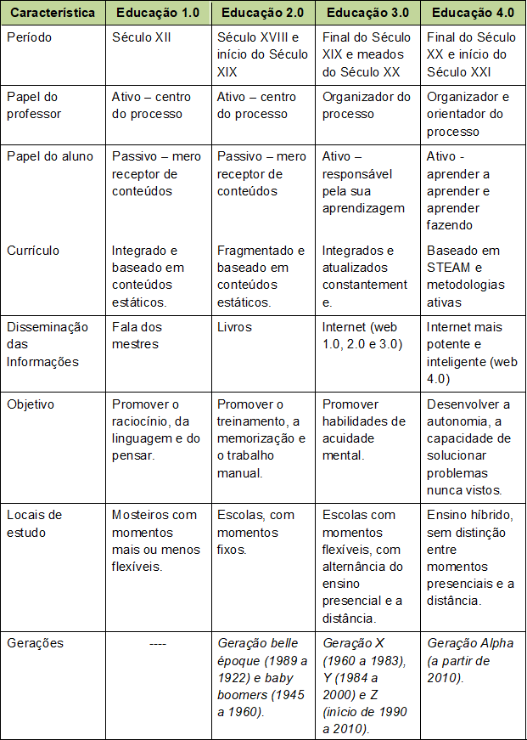

Source: Passos (2019).

The table above is a synthesis of the periods listed, which present the main characteristics of forms of access to knowledge, pertinent indications when observing the subjects involved in the processes (teachers and students) and their positions in the teaching and learning relations, the sources of consultations for knowledge, forms of knowledge dissemination, environments for the development of learning and the generations of teaching.

We understand that the field of knowledge is not static. Otherwise, it is in constant progression and refinement of its techniques, technologies and forms of interactions between subjects and the media. Thus, we understand that no didactic or methodological approach or appropriation format ends in a historically delimited period. These approaches span time and are paths to other proposals or are found in the same ones with different formats.

We approached the conception of Felcher and Folmer (2021, p. 4) to better understand these phases, which, according to the authors, "are related to the events that have marked and mark society over the years". We can understand that these transformations are linked to factors that involve, together, the philosophical perspectives of the educational field and the social, economic and technological movements.

We highlight, as well as the authors, the influence of historical movements, such as the Enlightenment and the industrial revolutions, as well as the creation of technological artifacts that expanded access to information. Simple examples include the Gutenberg printing press and, more recently, the popularization of the internet, virtual learning environments, and digitally accessible devices such as computers and smartphones, and the development of artificial intelligence.

**Figure 1**

*Brief summary of human development with technologies*

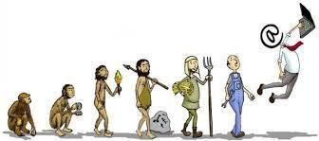

Sources: Technosociability and PNGEGG.

The analyses presented focus mainly on the Western Hemisphere and show the evolution of human interaction, methodologies, techniques and the use of technologies in educational processes. As civilization advanced in its social relations and used technology to improve the quality of life and survival, its use expanded beyond the exploitation of natural phenomena — such as the mastery of fire or the manufacture of wooden tools. Over time, greater control over nature and the systematization of knowledge have enabled humanity to develop more advanced tools, although access to them is not uniform, creating unequal and, in some cases, segregating learning opportunities.

**Figure 2**

*Timeline and some technological progress of humanity*

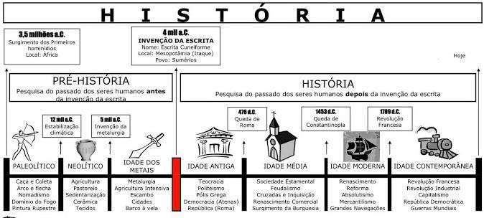

Source: The story that moves the world.

In the educational field, technologies and ways of conceiving and mediating learning have also gone through different stages. Fava (2014) identifies Education 1.0 as corresponding to the historical period that goes from Classical Antiquity to the European Cultural Renaissance, marked by the strong influence of the Catholic Church. The first official institutions, the Parish Schools, were dedicated to ecclesiastical formation. The pedagogical model was predominantly oral, with little participation of the learners and direct transmission of knowledge.

**Figure 3**

*Educational model in Europan monasteries; Jesuit education in Brazil*

Source: Passos (2019) ; Timetoast.

Education 2.0, in turn, dates back to the period of industrialization that began in the eighteenth century, whose methodologies were incorporated into the educational field, influenced by the conceptions of the American engineer Frederick Taylor. The standardization of industrial spaces and procedures, as well as the fragmentation of disciplines and the centralization of cognitive skills aimed at the execution of tasks, were adapted to schools, especially to train qualified labor.

The teacher assumed the role of master, directing and controlling the teaching process. This model gained strength near the factories and contributed to the expansion of education in a more open way to society. It is important to emphasize that educational models have not completely replaced themselves; Several of them coexisted over time, varying according to the social profile and the interests of public policies.

**Figure 4**

*Classroom Mutual teaching (Lancaster Method). Classroom, 1811*

Source: History of Brazilian Education.

At the end of the twentieth century, digital technology and the popularization of the internet transformed educational contexts, characterizing what is understood as Education 3.0. Fava (2014) highlights that this model privileges discourses of innovation and approximation between individuals, with reduced boundaries and new ways of teaching and learning, valuing scientific construction and artistic expression. The expectation of greater democratization of access to digital technologies, especially in Distance Education, has generated advances, but has not always reflected reality, due to gaps in implementation, management, infrastructure and pedagogical quality.

**Figure 5**

*Lesson template in 3.0 format.*

Source: Agência Minas.

Technology, when used to bring people together and create collaborative environments, still faces significant barriers in Brazil. Many computer labs remain inoperative, either due to lack of maintenance or commercial use, more focused on the exploitation of resources than on effective pedagogical mediation.

In the twenty-first century, Education 4.0 has been consolidated, driven by the fourth industrial revolution (SCHWAB, 2016) and by the technical-scientific advancement of digital tools (FÜHR; HAUNBENTHAL, 2018). Technologies such as robotics, artificial intelligence, big data, virtual reality, online repositories and virtual learning environments, along with methodologies centered on the student's "know-how", have become central concepts. The maker culture, which values "learning by doing" (ANTUNES, 2017), and active methodologies (MORAN, 2018) promote the student's protagonism, with the teacher acting as a mediator.

The BNCC (2018) reinforces this perspective, defining competence as the mobilization of knowledge, skills, attitudes, and values to solve complex demands of daily life, the exercise of citizenship, and the world of work. Education must, therefore, affirm values and foster actions that transform society, making it fairer and focused on environmental preservation.

Education 4.0 has consolidated itself as a central movement in the twenty-first century, driven by the so-called fourth industrial revolution, characterized by the exponential advance of digital technologies and the transformation of productive, social, and educational processes (SCHWAB, 2016). This scenario is marked by the technical-scientific development of digital tools, which have become part of pedagogical practices and the organization of knowledge on a daily basis (FÜHR; HAUNBENTHAL, 2018). Technologies such as robotics, artificial intelligence, big data , virtual reality, digital repositories, virtual learning environments and the intensive use of the internet constitute the central vocabulary of Education 4.0, reflecting a paradigm that privileges the know-how of students, that is, the practical application of knowledge in a contextualized and innovative way.

Within this context, concepts emerge that bring the school closer to contemporary culture, such as maker culture, a term that refers to the practice of "making with one's own hands" (ANTUNES, 2017), and active methodologies, which promote project-based learning, problem-solving, and collaborative experiences (MORAN, 2018). These approaches seek to decentralize teaching, reducing the exclusive role of the teacher and expanding the engagement of students, who start to take an active role in the construction of knowledge, strengthening skills such as autonomy, creativity and critical thinking.

On the didactic-pedagogical level, the role of the teacher remains essential as a mediator of learning. Pedagogical mediation is characterized as a regulatory process capable of guiding, organizing and systematizing knowledge, ensuring that students can transform information into applicable knowledge (VYGOTSKY, 2003). Collaborative projects, interdisciplinary work, and activities focused on student protagonism are examples of practices that are part of Education 4.0 and are recommended in official documents, such as the National Common Curriculum Base (BNCC), which defines ten essential competencies for the integral development of the student.

According to the BNCC (2018, [s.p.]), competence is:

"the mobilization of knowledge (concepts and procedures), skills (practical, cognitive and socio-emotional), attitudes and values to solve complex demands of daily life, the full exercise of citizenship and the world of work. By defining these competencies, the BNCC recognizes that education must affirm values and stimulate actions that contribute to the transformation of society, making it more humane, socially just, and also focused on the preservation of nature."

In High School, there is an emphasis on disciplines accompanied by the expression "and their technologies", reflecting the need to integrate ICT in the educational process. The goal is to create meaningful learning environments in which students understand the historical, social, and functional use of technologies, contextualizing their learning, and promoting relationships between theory and practice.

**Figure 6**

*General competencies of the BNCC*

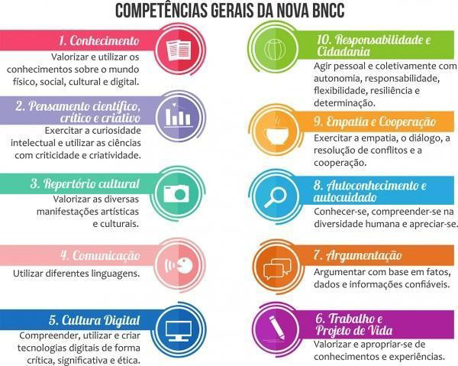

Source: INEP.

Despite the advances, some recent approaches, such as self-instruction and homeschooling, have generated critical debates, especially about the reduction of teacher presence. Although access to digital content has significantly expanded learning opportunities, pedagogical mediation continues to be indispensable to organize, evaluate, and deepen the knowledge acquired, ensuring the construction of complex skills and the integral formation of students.

Pedagogical mediation, based on Vygotsky's (2003) Zone of Proximal Development (ZDP), highlights the importance of collaborative and culturally situated interaction. Technologies, in this sense, work as facilitating tools, allowing students and teachers to interact with knowledge, assign meanings, and integrate historical and cultural experiences into the educational process. The intentional use of digital resources is not limited to simple access to content, but should favor critical reflection, knowledge construction, and socio-emotional development.

The implementation of Education 4.0, however, faces significant challenges. Oliveira (2019) points out that, in many contexts in developing countries, students remain passive, limiting themselves to the absorption of content, which contrasts with Education 4.0's emphasis on experimentation, production, and student protagonism. Consolo (2020) deepens the analysis, highlighting factors such as insufficient infrastructure, family support, teacher motivation, and student engagement as barriers to the consolidation of this approach.

In Brazilian institutions, structural problems, such as scrapped laboratories, low connectivity and restrictions on the use of smartphones, compromise the effectiveness of ICT implementation (FELCHER; FOLMER, 2021; PATEL; FEITOZA, 2017). The COVID-19 pandemic has further highlighted these gaps, demonstrating the urgency of public policies that promote digital inclusion, equitable access to technologies, and engagement strategies that keep students connected to learning.

**Figure 7**

*Dilemmas arising from DICT*

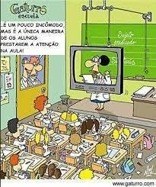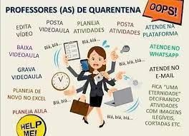

Source: LAPEGEO; Brasil de Fato.

In view of this scenario, Education 5.0 proposals emerge, which expand the principles of Education 4.0 by valuing technical, socio-emotional and practical skills, promoting the integration of human beings with technology in an ethical and inclusive way. Education 5.0 proposes flexible and democratic curricula, capable of articulating different areas of knowledge and fostering the active participation of the school community, including those historically marginalized by the digital divide.

Active methodologies, living schools and engaged school communities are fundamental elements of this new perspective, ensuring that the school is a dynamic space, connected to the life of the student and protagonist in the formation of citizenship. The experiences of social distancing have highlighted the need for adaptive strategies, integrating digital technologies with pedagogical practices centered on the integral development of the student.

**Figure 8**

*Distance Education in Brazilian Elementary Education*

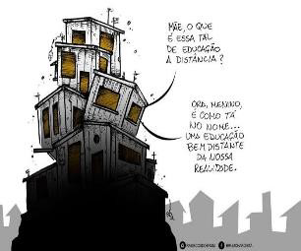

Source: Free Journalists.

Education 5.0, therefore, represents a horizon of possibilities, in which innovative technologies and methodologies are instruments to enhance cognitive, practical, and socio-emotional skills, ensuring that the school acts as a space for the production of knowledge, social inclusion, and ethical training. The consolidation of this approach requires a joint effort by teachers, managers, students and society, aiming to build dynamic, contextualized educational processes capable of facing the challenges of the twenty-first century.

Among some premises for successful construction, we highlight some conceptions addressed by Bacich and Moran (2018)

❖Space and Relational

Interpersonal relationships – In the contemporary educational context, communication and interaction skills play a central role in the construction of meaningful bonds between teachers and students, promoting not only close contact, but also the constant exchange of knowledge. The mastery of DICT by young people, often pointed out as a justification for student protagonism, should not override the valorization of teacher-student collaboration. Knowledge is the result of collective processes and mobility between subjects, being built through interactions that involve exchanges of experiences, challenges and shared learning, both in analog and digital environments.

The role of the student and the teacher – Both teachers and students actively build their educational identities, guided by horizontal relationships of communication and cooperation. The student is encouraged to take a leading role, taking responsibility for their learning, developing autonomy and participating in collaborative activities. The teacher, in turn, acts as a mediator, organizer and enhancer of knowledge, guiding the appropriation of digital technologies and web tools. This role is close to that of a corporate manager, as it involves coordinating groups, elaborating problem situations, conducting feedback, evaluating performance by pedagogical metrics, and using online academic management systems. The teaching role requires, therefore, not only knowledge of content, but leadership and mediation skills in hybrid and digital environments.

Learning space and environments – With the incorporation of ICT, the physical classroom was redefined and extended to virtual, synchronous and asynchronous environments, allowing pedagogical mediation in multiple formats. Industry 4.0, cyberculture and cyberspace have contributed to popularizing technological resources in education. However, the creation of forums or the presence of digital tutors cannot be confused with effective pedagogical mediation. Experiences such as real-time web classes , participation in international events, and symposiums have shown that it is possible to qualify remote learning, but factors such as equipment availability, connectivity, infrastructure, and the ability of the target audience to operate limit the reach of these practices.

❖ Methodologies

Teaching methodology – Active methodologies are fundamental to promote meaningful learning, valuing the use of digital technologies as instruments of pedagogical mediation and access to information (MORAN, 2018). The presentation of problem-situations, collective work, individual research and discoveries of personal and group motivations are essential premises. The teacher acts as a mediator, proposing themes and assisting in the acquisition of content and skills, interfering in a strategic way, unlike the traditional teacher-centered model.

Hybrid teaching – This modality combines face-to-face, blended and distance learning, using computers, smartphones, artificial intelligence, augmented reality, synchronous and asynchronous web classes. The flexibility of hybrid teaching allows access to activities and pedagogical mediation even in remote regions. During the pandemic, this approach became essential to maintain the educational bond, adapting quickly to different contexts and health restrictions.

Problem-Based Learning (PBL) – Education 5.0 prioritizes learning by solving contextualized problems, allowing students to apply prior knowledge and explore new solution strategies, preferably in groups. The teacher assumes the role of mediator, offering punctual support and guidance in the use of digital tools. Polya (1995) suggests an efficient model of problem solving: reading and interpretation of the statement, planning of the solution, execution and validation of the results, promoting logical reasoning and student autonomy.

Personalization and adaptability of teaching – The New High School (BNCC, 2018) allows students to choose training itineraries, delving into areas of interest. Adaptive learning, through digital data analysis, makes it possible to monitor performance in real time and propose individual activities, strengthening specific skills and correcting learning gaps.

Computational thinking and gamification – Computational thinking, integrated with the use of ICT, enables students to structure problems, develop solutions, and understand complex processes, using concepts such as abstraction, decomposition, and pattern recognition (BRACKMANN, 2017). Gamification introduces playful and interactive elements, stimulating motivation, healthy competition, and cooperation, making learning dynamic and engaging. Digital or analog games can be structured with goals, rewards, and progress, allowing for trial-and-error learning.

Flipped classroom and Maker Education – The flipped classroom model (VALENTE, 2014) proposes that the student studies the content beforehand, using the classroom for practical activities, discussions and collaborative projects. Maker Education, according to Blinkstein; Valente and De Moura (2020), combines science, technology, and creativity, promoting practical learning through robotics, 3D printers, and specific laboratories. Papert (1986) reinforces that constructionism values the production of objects of interest to the student as a catalyst for engagement and learning.

❖ Technologies, digital inclusion and social challenges

The pandemic has highlighted inequalities in access to technologies, exposing the so-called "digital peripheries", where students face connectivity barriers, financial limitations, and lack of adequate devices. Public policies, VLE, and blended learning were not enough to ensure total equity. While higher education has physical and virtual laboratories, many basic schools lack the minimum infrastructure to implement effective digital practices.

Virtual and augmented reality – Advanced multimedia resources, such as glasses, sensors, and headphones, enable immersive experiences, increasing engagement and facilitating pedagogical mediation (KIRNER; TORI, 2006). Virtual and physical laboratories expand the theoretical-methodological approach, making the classroom a flexible, interactive and continuous learning space (MORAN; MASETTO; BEHRENS, 2011).

Management, neuroscience and socio-emotional skills – Integrated management systems optimize data recording and academic processes. Computational thinking and neuroscientific studies allow us to understand how students learn and deal with cognitive, emotional, and socio-emotional aspects, helping teachers to build strategies for welcoming and managing groups in the face of behavioral crises, anxiety, or depression, especially in periods of social isolation.

**3 FINAL CONSIDERATIONS**

Digital tools, as well as other technologies throughout history, play a central role in democratizing access to information and building knowledge. Just as the Gutenberg printing press made it possible to popularize books, the internet and current digital technologies have exponentially expanded the possibilities of access to information, allowing knowledge to circulate in a faster, more comprehensive and diversified way. These technological resources have the potential both to promote social and educational benefits and to generate inequalities and misuse, depending on how they are appropriated.

In this way, the family, the community and society in general play a fundamental role. It is necessary that they act in partnership with school institutions and their professionals, promoting social engagement actions, disseminating scientific knowledge, encouraging active citizenship practices and strengthening the educational role of the school as a transforming agent of society.

Pedagogical mediation assumes, therefore, a strategic and essential role in the appropriation of these technologies. It is not limited to the introduction of digital resources, but involves planning, guiding, and supervising the proper use of these tools in school activities, as well as in the promotion of social practices inside and outside the educational environment. Encouraging the conscious use of computer labs, which cannot remain underutilized, promoting the use of smartphones and other digital devices for research and critical learning, as well as stimulating reflection and investigation beyond ready-made answers found in search engines, are concrete examples of effective pedagogical actions.

At the same time, it is essential to curb and raise awareness among students about the misuse of these resources, considering that practices such as inappropriate access to social networks, games without pedagogical purposes and even cyberbullying can compromise the cognitive, emotional and social development of students. Digital education, therefore, must combine learning and responsibility, promoting technological, cognitive and ethical skills.

We start from the principle that knowledge is built collaboratively, and that learning should not be limited to rigid curricular structures, but rather be a dynamic, flexible and interconnected process, capable of integrating different knowledges. For this joint construction to occur effectively, it is necessary to critically analyze the current curricular policies, identifying how they foster or sometimes restrict the pedagogical work mediated by DICT, as well as considering the contributions of researchers in the area, including specific studies.

Digital resources, in their multiple forms and applications, require special attention, as their effectiveness depends on the context in which they are used, the way they reach users and the dynamics that are promoted around them. It is essential to evaluate and problematize the use of technologies, understanding the intentions behind their manipulation and the scenarios in which they can be applied, in order to analyze the possible interactions between knowledge, usability and interpretation of information.

In this sense, immersion in the school space, in cyberspace and in the universe of digital knowledge is essential to map and understand the most used tools, as well as their potentialities and limitations. Observing recent trends and practices allows us to identify how these technologies are being appropriated, which learning is favored, what barriers still exist and how they can be overcome in the educational context. This continuous monitoring is crucial to guide policies, pedagogical practices and teacher training strategies, ensuring that digital technologies are effectively integrated into the teaching and learning process in an ethical, critical and productive way.

**REFERENCES**

Alves, M., André, C. F., & Méndez, N. D. D. (2020). Microlearning na educação corporativa e em tempos de Geração C. Revista Intersaberes, 15(34). https://doi.org/10.22169/revint.v15i34.1709

Antunes, J. (2017). A Educação 4.0 já é realidade! Tecnologia Educacional. Retrieved May 22, 2025, from https://tecnologia.educacional.com.br/educacao-4-0/a-educacao-40-ja-e-realidade/

Bacich, L., & Moran, J. (Eds.). (2018). Metodologias ativas para uma educação inovadora: Uma abordagem teórico-prática. Porto Alegre: Penso Editora.

Blikstein, P., Valente, J. A., & de Moura, É. M. (2020). Educação maker: Onde está o currículo? Revista e-Curriculum, 18(2), 523–544. https://doi.org/10.23925/1809-3876.2020v18i2p523-544

Brackmann, C. P. (2017). Desenvolvimento do pensamento computacional através de atividades desplugadas na educação básica (Doctoral dissertation). Universidade Federal do Rio Grande do Sul, Porto Alegre.

boyd, d., & Crawford, K. (2011). Six provocations for big data. In A decade in internet time: Symposium on the dynamics of the internet and society (pp. 1–17). Oxford: Oxford Internet Institute. Retrieved May 22, 2025, from http://papers.ssrn.com/sol3/papers.cfm?abstract_id=1926431

Brasil. (2016). Constituição da República Federativa do Brasil. Brasília, DF: Presidência da República. Retrieved from http://www.planalto.gov.br/ccivil_03/constituicao/constituicaocompilado.htm

Brasil. Ministério da Educação. (2018). Base Nacional Comum Curricular. Brasília: Ministério da Educação.

Consolo, A. T. G. (2020). Educação 4.0: Onde vamos parar? In S. Garcia (Ed.), Gestão 4.0 em tempos de disrupção (pp. 94–115). São Paulo: Blucher.

Dewey, J. (1916). Democracy and education. New York: The Free Press.

Fava, R. (2014). Educação 3.0: Aplicando o PDCA nas instituições de ensino. São Paulo: Saraiva.

Felcher, C. D. O., & Folmer, V. (2021). Educação 5.0: Reflexões e perspectivas para sua implementação. Revista Tecnologias Educacionais em Rede (ReTER), 2(3), e5/01–15. https://doi.org/10.30612/reter.v2i3.67227

Führ, R. C., & Haubenthal, W. R. (2018). Educação 4.0 e seus impactos no século XXI. Educação no Século XXI, 36, 61.

Freinet, C. (1998). Educação pelo trabalho. São Paulo: Martins Fontes.

Freire, P. (2008). Pedagogia da autonomia: Saberes necessários à prática educativa. São Paulo: Paz e Terra.

Junior, G. de B. V., et al. (2020). Você está preparado para a Educação 5.0? Revista CPAQV–Centro de Pesquisas Avançadas em Qualidade de Vida, 12(1), 2.

Kirner, C., & Tori, R. (2006). Fundamentos de realidade aumentada. In Fundamentos e tecnologia de realidade virtual e aumentada (Vol. 1, pp. 22–38).

Moran, J. M., Masetto, M. T., & Behrens, M. A. (2011). Novas tecnologias e mediação pedagógica (19th ed.). Campinas: Papirus.

Montessori, M. (1965). Spontaneous activity in education. New York: Schocken Books.

Moran, J. M. (2018). Metodologias ativas para uma aprendizagem mais profunda. In L. Bacich & J. Moran (Eds.), Metodologias ativas para uma educação inovadora: Uma abordagem teórico-prática (pp. 1–25). Porto Alegre: Penso.

Oliveira, E. F. de. (2019). Ensino de Geografia e educação 4.0: Caminhos e desafios na era da inovação. Revista Amazônica sobre Ensino de Geografia, 1(1).

Passos, M. L. S. (2019, August 30). Da Educação 1.0 a Educação 4.0: Os caminhos da educação e as novas possibilidades. Página Marize Passos. Retrieved May 22, 2025, from https://www.marizepassos.com/post/educação-1-0-a-educação-4-0-os-caminhos-da-educação-e-as-novas-possibilidades-para-a-educação

Papert, S. (1986). Constructionism: A new opportunity for elementary science education. Proposal to the National Science Foundation, Massachusetts Institute of Technology, Media Laboratory, Epistemology and Learning Group, Cambridge, MA.

Pimentel, F. S. C., & Feitoza, M. J. S. (2017). O uso da tecnologia móvel (celular) no contexto educacional. Revista Educação a Distância e Práticas Educativas Comunicacionais e Interculturais, 17(3), 129–139.

Polya, G. (1995). A arte de resolver problemas: Um novo aspecto do método matemático (H. L. de Araújo, Trans.). Rio de Janeiro: Interciência.

Soares, K. P. (2022). História, educação e games: Literatura gamer em história no século XXI (Doctoral dissertation). Universidade Estácio de Sá, Rio de Janeiro.

Valente, J. A. (2018). A sala de aula invertida e a possibilidade do ensino personalizado: Uma experiência com a graduação em midialogia. In L. Bacich & J. Moran (Eds.), Metodologias ativas para uma educação inovadora: Uma abordagem teórico-prática (pp. 26–44). Porto Alegre: Penso.

Vigotski, L. S. (2003). Formação social da mente (6th ed.). São Paulo: Martins Fontes.

1. Dr. in education. Universidade Estácio de Sá (UNESA). ORCID: 0000-0002-2532-7881
2. Dr. in education. Pontifícia Universidade Católica do Rio de Janeiro (PUC-Rio).

   ORCID: 0000-0002-8844-2043